HCLTech 60-Day Training
DAY 12 • SELENIUM AUTOMATION
Locators • Navigation • Web Form Testing - 07 October 2026
Name | Logesh.N.A
Register No. | 212223240078
1. Assignment
Day 12 – Selenium Locators, Navigation, Web Form Testing – 06-10-2026
Assignment II: Selenium automation scripting task.
2. Task
Automate the Amazon website using Selenium WebDriver: log in, search for a product, open the selected product, add it to the cart, and proceed through the cart flow.
3. Automation Work Completed
- Opened Amazon India using Selenium WebDriver.
- Automated the login flow using explicit waits and Selenium locators.
- Searched for a bag product.
- Located and opened the selected product.
- Switched to the newly opened browser window.
- Added the product to the cart.
- Opened the cart and proceeded to checkout.
4. Selenium Concepts Used
Concept | Used In Script | Purpose
By.ID | Search box, password, buttons | Locate elements by ID
By.XPATH | Login, product and cart | Locate elements using XPath
WebDriverWait | Page interactions | Wait for elements
Expected Conditions | element_to_be_clickable | Wait until clickable
send_keys() | Login and search | Enter text
click() | Buttons and product | Perform clicks
switch_to.window() | Product page | Switch browser window
6. Code
from selenium import webdriver
from selenium.webdriver.common.by import By
from selenium.webdriver.support.ui import WebDriverWait
from selenium.webdriver.support import expected_conditions as EC
import time
driver=webdriver.Chrome()
driver.get("https://www.amazon.in/")
wait=WebDriverWait(driver,10)

driver.maximize_window()

login=wait.until(
EC.element_to_be_clickable(
(By.XPATH,'//*[@id="nav-link-accountList"]/button')
)
)
driver.execute_script(
"arguments[0].scrollIntoView({block: 'center'});",
login
)

driver.execute_script(
"arguments[0].click();",
login
)
print("login clicked success")
signin=wait.until(
EC.element_to_be_clickable(
(By.XPATH,'//*[@id="nav-flyout-ya-signin"]/a/span')
)
)
driver.execute_script(
"arguments[0].scrollIntoView({block: 'center'});",
signin
)

driver.execute_script(
"arguments[0].click();",
signin
)
print("signin success")
mobile=wait.until(
EC.element_to_be_clickable(
(By.ID,"ap_email_login")
)
)
mobile.click()
mobile.send_keys("891111111189")
button=wait.until(
EC.element_to_be_clickable(
(By.XPATH,'//*[@id="continue"]/span/input')
)
)
button.click()
print("success")

password=wait.until(
EC.element_to_be_clickable(
(By.ID,'ap_password')
)
)
password.send_keys("amazonhamazon")

signin=wait.until(
EC.element_to_be_clickable(
(By.ID,"signInSubmit")
)
)
signin.click()

print("Login Successfully")

searchbox=wait.until(
EC.element_to_be_clickable(
(By.ID,"twotabsearchtextbox")
)
)
searchbox.send_keys("Bag")
searchbox.click()

searchicon=wait.until(
EC.element_to_be_clickable(
(By.ID,"nav-search-submit-button")
)
)
searchicon.click()

print("Product Shown Success")

driver.execute_script("window.scrollBy(0,500);")

productPage = wait.until(
EC.element_to_be_clickable
(
(By.XPATH, "//span[contains(text(),'Aristocrat Nova 15L Laptop Backpack (15.6\"), 2 Com')]")
)
)

driver.execute_script(
"arguments[0].scrollIntoView({block: 'center'});",
productPage
)

productPage.click()

print("Product clicked")

wait.until(lambda d: len(driver.window_handles) > 1)

driver.switch_to.window(driver.window_handles[-1])

print("Product page opened")
print("Current URL:", driver.current_url)

cartbutton=wait.until(
EC.element_to_be_clickable(
(By.XPATH,'//input[@id="add-to-cart-button"]')
)
)

cartbutton.click()
print("cart added success")

gotocart=wait.until(
EC.element_to_be_clickable(
(By.XPATH,'//*[@id="sw-gtc"]/span/a')
)
)
gotocart.click()

print("gotocart success")

proceed=wait.until(
EC.element_to_be_clickable(
(By.XPATH,'//*[@id="sc-buy-box-ptc-button"]/span/input')
)
)

proceed.click()

time.sleep(30)

6. Screenshots / Evidence
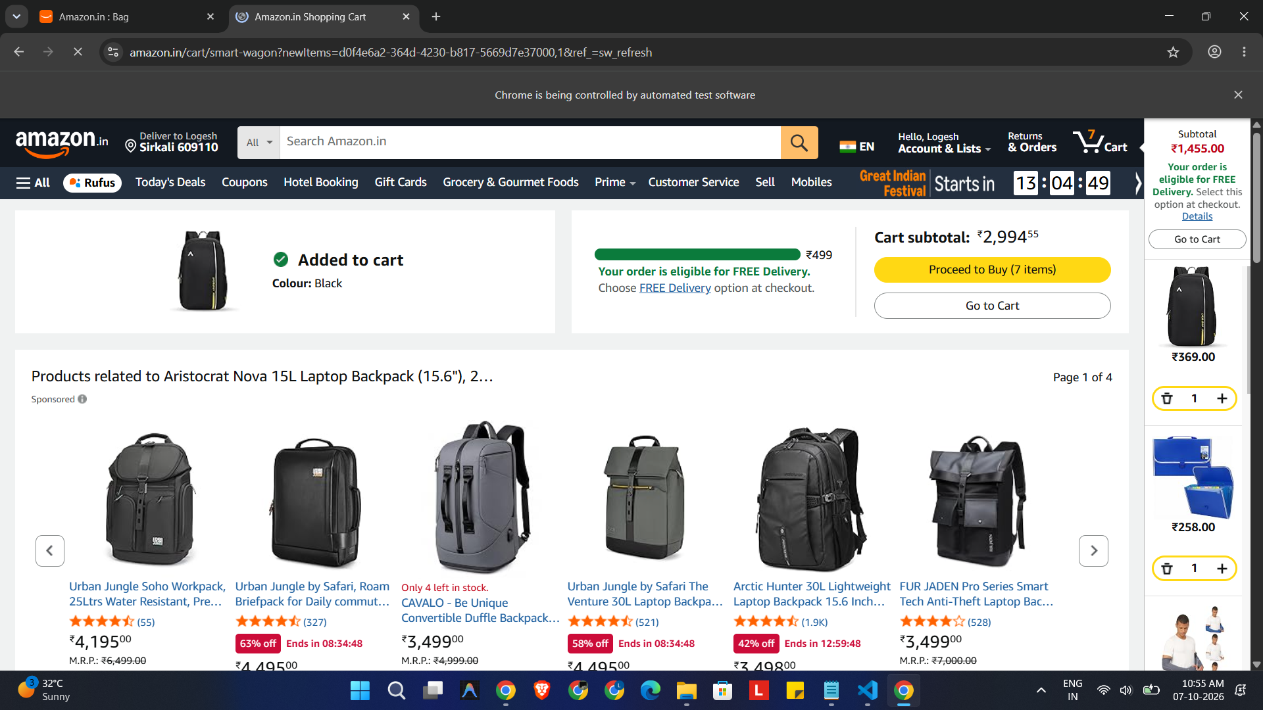

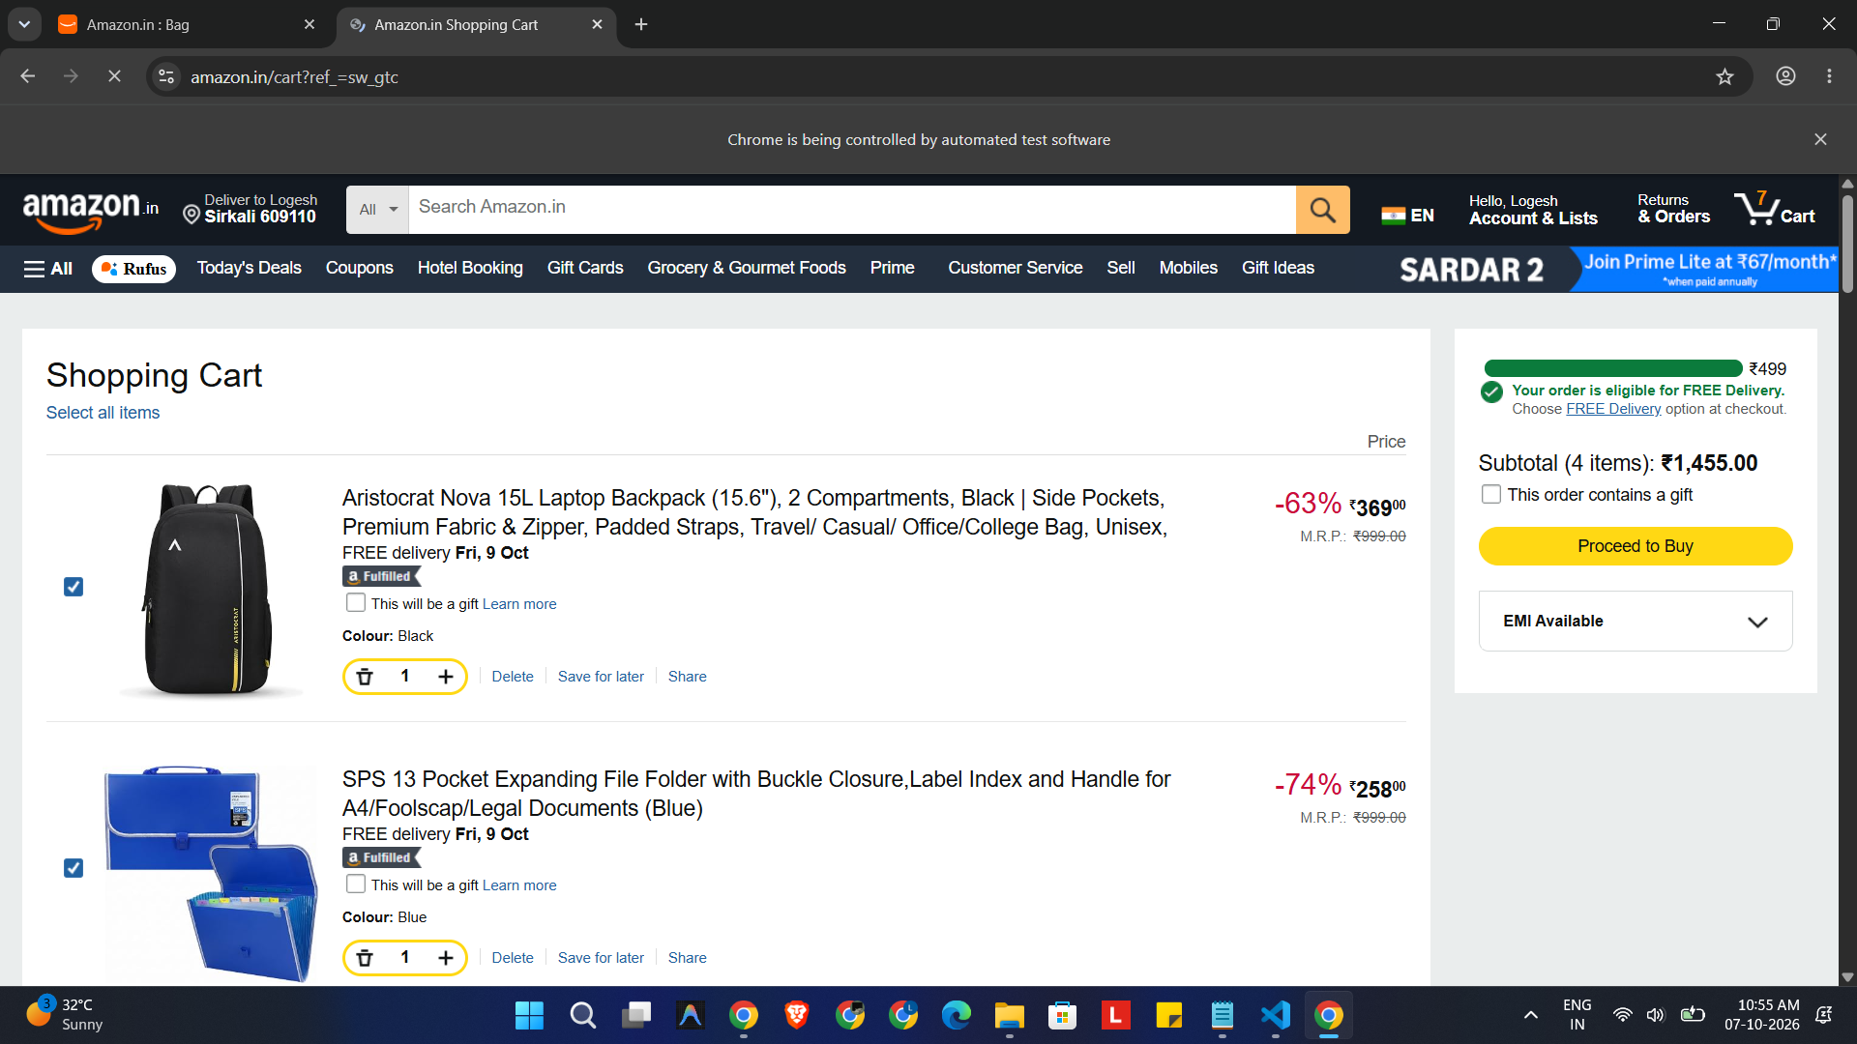
8. Result
Successfully completed the assigned Amazon automation flow using Selenium WebDriver, including login, product search, product selection, and cart automation.

